USING A CALCULATOR
Pearson Edexcel - Tuesday 11 June 2019 - Paper 3 (Calculator) Foundation Tier

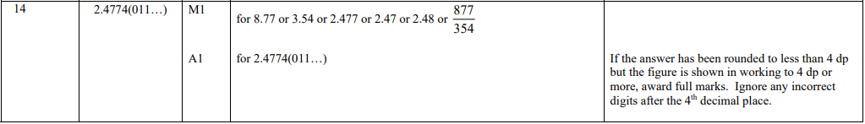

Pearson Edexcel - Monday 12 November 2018 - Paper 3 (Calculator) Foundation Tier

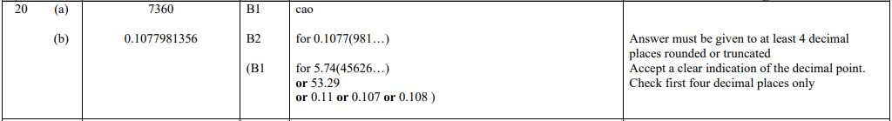

Pearson Edexcel - Monday 6 November 2017 - Paper 2 (Calculator) Foundation Tier

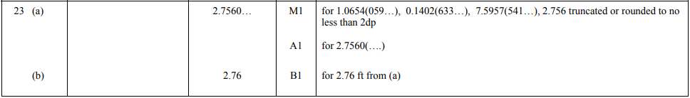

AQA Thursday 8 November 2018 – Morning (Calculator) Foundation Tier

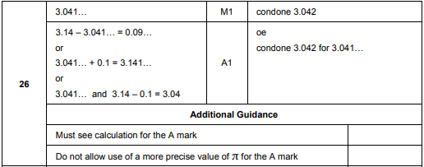

AQA Monday 6 November 2017 – Morning (Calculator) Foundation Tier

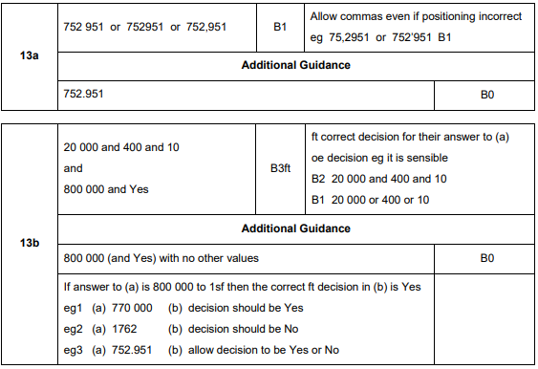
AQA Thursday 8 June 2017– Morning (Calculator) Foundation Tier

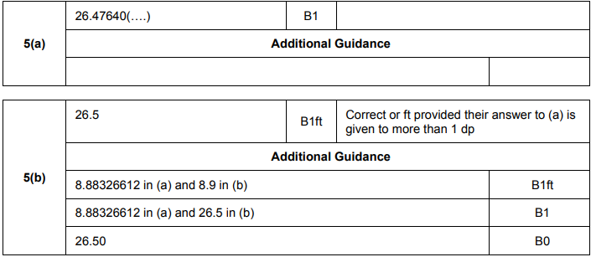

AQA Sample Paper 3– Morning (Calculator) Foundation Tier

